<https://blog.csdn.net/nieshanfeng1/article/details/38769573>

链接securCRT ,一直显示connection close

打开宝塔cmd:

测试ssh连接：

ssh localhost

提示连接不上：[SSH problem - Read from socket failed: Connection reset by peer](http://askubuntu.com/questions/205179/ssh-problem-read-from-socket-failed-connection-reset-by-peer)

[SSH 错误解决案例1：Read from socket failed: Connection reset by peer](https://www.cnblogs.com/biangbiang/p/4818496.html)

<https://www.cnblogs.com/biangbiang/p/4818496.html>

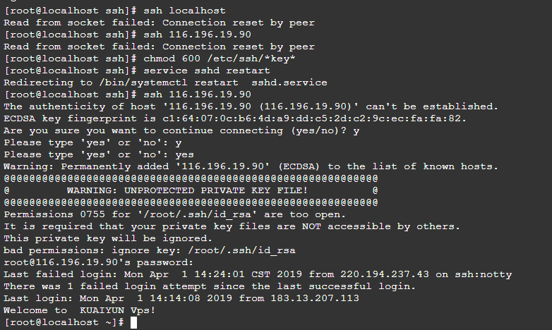

 先解决这个错误吧

chmod 600 /etc/ssh/*key*

// 重启ssh

service sshd restart